1. A New Fact Table Name SalesRecord is made.

It maintains the entry for each ProductService/Merchandise bought.

It has following fields:

* SalesRecordNo (Primary Key)
* SalesQty (As it is in Contains Table)
* SalesUnitPrice (Price of Merchandise, Price of Service may be ServiceCategory, Special Events, Membership Price from MemberType Table)
* SalesTotalAmt (Track of Total Money Earned)
* IsService (Yes or No): To check entry recorded is of Service or not.
* IsMerchandise (Yes or No): To check Entry recorded is of merchandise or not.

1. Other 5 dimension tables are as follows:
   1. Franchise
      1. FranchId (primary key)
      2. FranchRegion
      3. FranchPostalCode
      4. FranchModelType
2. Member
   1. MmbrId (Primary Key)
   2. MmbrName
   3. MmbrZip
   4. MmbrDate
   5. MmbrEmail
   6. MmbrType (Taken from ERD MmbrType Table)

(Default values for Guest, Corporate Cust)

1. Calendar
   1. CalId (primary key)
   2. CalDay
   3. CalMonth
   4. CalYear
2. ProductService
   1. ProdId(Primary Key)
   2. ProdName
   3. ProdType (Special Event, Service, MemberShip)
3. Merchandise
   1. MerchId (Primary Key)
   2. MerchName
   3. MerchType
4. SalesRecord of ProductService/Merchandise Bought By Member On Calendar Supplied By Franchise

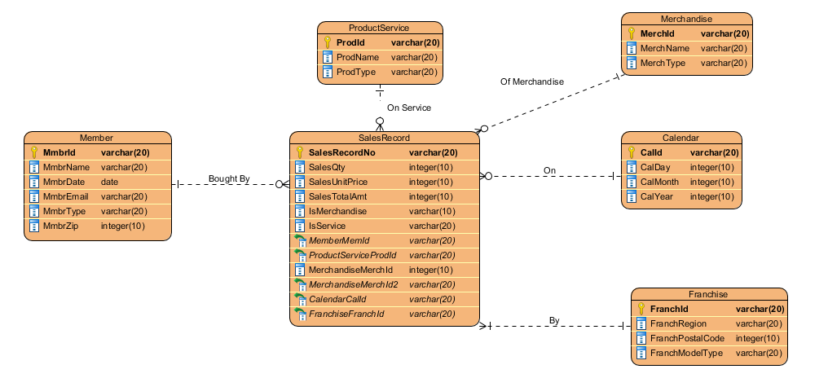

The diagram shows the star schema with SalesRecord as the middle and other dimensions have 1 to many relationships to it.

Each entry into the database contains the record of the ProductService whether it is Service or Special Event into the database or Membership (Gold, Platinum, Value) or of merchandise.